**MODULE: 4.1 (C++ Basic)**

• What is OOP? List OOP concepts

Ans🡪 Object Oriented programming as the name suggest user objects in programming. Object oriented programming aims to implement real world entities like inheritance, hiding, polymorphism, etc. in programming. The main aim or OOP is to bind together the data and the functions that operate on them so that no other pars of the code can access this data except that function…

Ther are some basic concepts that part act as the building blocks of OOPs…..

1. CLASS
2. OBJECTS
3. ENCAPSULATION
4. ABSTRACTION
5. POLYMORPHION
6. INHERITANCE
7. DYNAMIC BINDING
8. MESSAGE PASSING

Characteristics of an Object Oriented Programming Language….

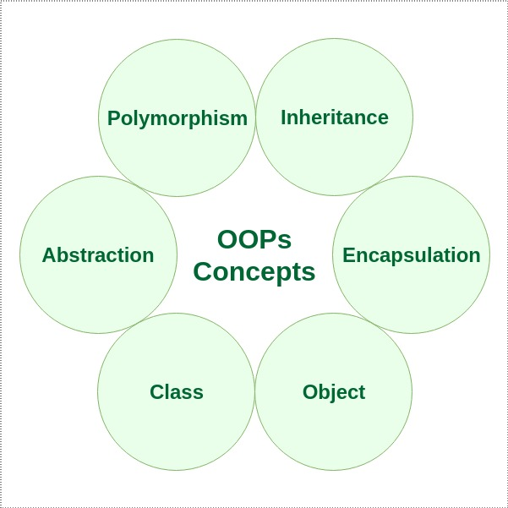

• What is the difference between OOP and POP?

Ans 🡪

|  |  |
| --- | --- |
| OOP | POP |
| 1. Programs are divided into part knows as Objects. | 1. In this Programs are   divider into Functions |
| 1. The main focus of oop is on the Data. | 1. The main focus of is on the Procedures. |
| 1. It follows bottom up approach. | 1. It follows top down   approach. |
| 1. It has access specifiers such as public, private etc. | 4.It this functions use global data. |
| 1. It Provides data associated with the program.so security is provide. | 5.POP dues not have any access specifiers.  POP doesnot provide any data security. |
| 6.Ease of modification | 6.Modification is difficult. |
| 7.Examples java, perl | 7.Examples c, COBOL etc. |